Found a save for Charlie end of week 4, saved to page 1 save 6, as Tom’s is page 2 save 6

Looking for an ending save for Michael

The latest save for Michael is 14 Dec at 21:45, but I suspect it might be a save from a run I messed up on

Oh yeah, she’s named MC in this one. It’s definitely Navy’s save.

Page 3 is officially Michael’s page, so save 6 on that one will have his end of week 4 save

Alright, made it to Week 3 Saturday, I’m pretty sure I’m on track to finish and test week 4

Wait, it said Sunday? Why is she locking up her office?

Oh I see. Run ended, it’s just perpetually giving me the same “Friday after work” dialogue and advancing days.

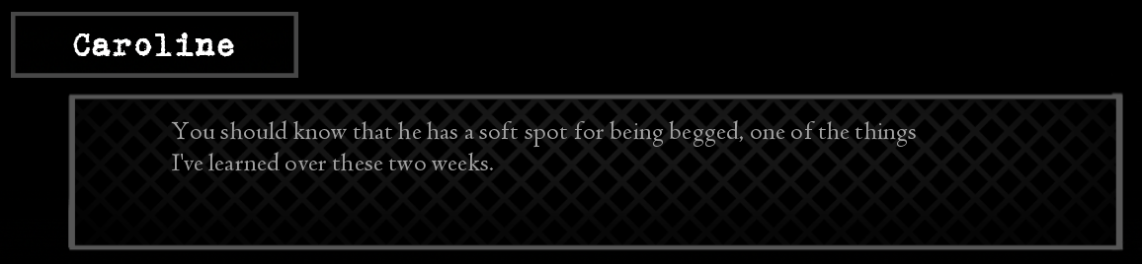

This should maybe be “those two weeks”

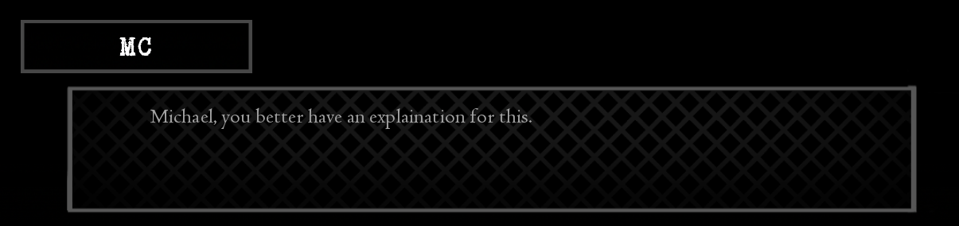

After Mother Harlot dream scene, but I assume you already fixed this since it happened after we talked about this word

Finished with Michael week 4 testing